Title: Wireless IoT Sensing System for Structural Health Monitoring

Brief:

This lecture covers the topics of wireless IoT sensing system and its applications in structural health monitoring (SHM). With the advancement of 4G/5G communication, edge/cloud computing infrastructure, and green artificial intelligence, great opportunities show up to upgrade traditional wireless smart sensors to wireless IoT sensing systems for next-generation wireless structural health monitoring systems. Though sharing several similar features, IoT sensing systems have their unique functionalities, such as IoT protocol-based communication and cloud-based data storage. In this lecture, we will discuss the fundamental knowledge, existing challenges, and emerging technologies for wireless IoT sensing systems, in the aspects of IoT protocols, edge/cloud computing, autonomous/remote operation. In particular, we will discuss the recent advances in wireless IoT sensing, including adaptive triggered sensing, self-diagnosis/recovery, and edge intelligence enabling AIoT network, as well as their applications in structural anomaly detections. Furthermore, full-scale applications will also be presented and discussed. In addition, to prepare for hands-on group projects, we will dedicate some time for prototype development of wireless sensors, which consists of microcontroller, MEMS accelerometers, radio transmitters, etc. Both knowledge of hardware and software will be introduced, assembly and programming procedure will be illustrated, and hands-on guidance and tips will be shared.

Budget for Arduino Node Components:
Item NO. | Item | Component | Description | Vendor | Unit Price (RMB) | Quantity | Total Price (RMB) | Link
1 | Main Control (non-consumable) | Arduino Uno R4 Devkit | main control board + sensors  (trigger sensor included) + accessories | Keyes | 730 | 1 | 730 | Link
2 | Main Control (non-consumable) | Arduino Uno R4 Wifi | Backup | Keyes | 134  235.2 | 1  2 | 268  470.4 | Link
3 | Extension Board (non-consumable) | Sensor Shield | extension board | Keyes | 9.8 | 2 | 19.6 | Link
4 | Accelerometer  (non-consumable) | MPU6050 | accelerometer | Keyes | 17  18.62 | 2 | 34  37.24 | Link
5 | RF Module (non-consumable) | nrf24l01 | wireless communication | Keyes | 10.7  10.78 | 2 | 21.4  21.56 | Link
6 | RTC Component (non-consumable)  (consumable) | RTC DS1307 | real time clock | Keyes | 10.7 | 2 | 21.4 | Link
7 | Power Supply (consumable) | Lithium Battery & Box | power supply | Keyes | 2.8 | 2 | 5.6 | Link
8 | Power Supply (consumable) | Battery | battery | 新星兄弟 | 46  48 | 2  1 | 92  48 | Link
9 | SD Card Module (non-consumable) | SD card module | SD card module | xyuanli | 3.02 | 2 | 6.04 | Link
10 | SD Card (non-consumable) | SD Card | SD Card 16 GB | Sandisk | 28.9 | 2 | 57.8 | Link
11 | Case (consumable) | Case | case | Keyes | 9 | 2 | 18 | Link
12 | Case (consumable) | 3D-print Case | case | 专业FDM打印⼯坊 | 0.2/g | 50g  260g | 20  52 | Link
13 | Multimeter ( non-consumable) | Multimeter | Multimeter | DELIXI | 78 | 2 | 156 | Link
14 | Dupont Wire (consumable) | Dupont Wire  male-female | Dupont Wire 10cm | telesky | 9.53 | 2 | 19.06 | Link
15 | Dupont Wire (consumable) | Dupont Wire  Female-female | Dupont Wire 15cm | telesky | 9.31 | 2 | 18.62 | Link
16 | Breadboard (consumable) | Breadboard | Breadboard Suit | Tmall | 39.8 | 2 | 79.6 | Link
 |  |  |  |  |  | TOTAL | 1433.12  750.32

Total for one suit: 1433.12 750.32 RMB
Total for 12 suits: 1433.12 750.32*12 = 17197.44 9003.84 RMB

Item NO. | Item | Component | Description | Vendor | Unit Price (RMB) | Quantity | Total Price (RMB) | Link
17 | RGBLED | RGBLED | Status Indication | Keyes | 12 | 1 | 12 | Link
18 | Battery Holder | Battery Holder | Battery Holder | - | 24.8 | 1 | 24.8 | Link
19 | Hex Standoff | Hex Standoff | Hex Standoff | - | 2.86 | 1 | 2.86 | Link
20 | Nut | Nut | Nut |  | 3.07 | 1 | 3.07 | Link
21 | Screw | Screw | Screw |  | 2.3 | 1 | 2.3 | Link
22 | Cloth Tape | Cloth Tape | Cloth Tape | - | 7 | 1 | 7 | Link
 |  |  |  |  |  | TOTAL | 52.03
The following items are newly added, not for reimbursement.

Total for one suit: 52.03 RMB
Total for 12 suits: 624.36 RMB

Item 1: Main Control - Arduino Uno R4 Devkit
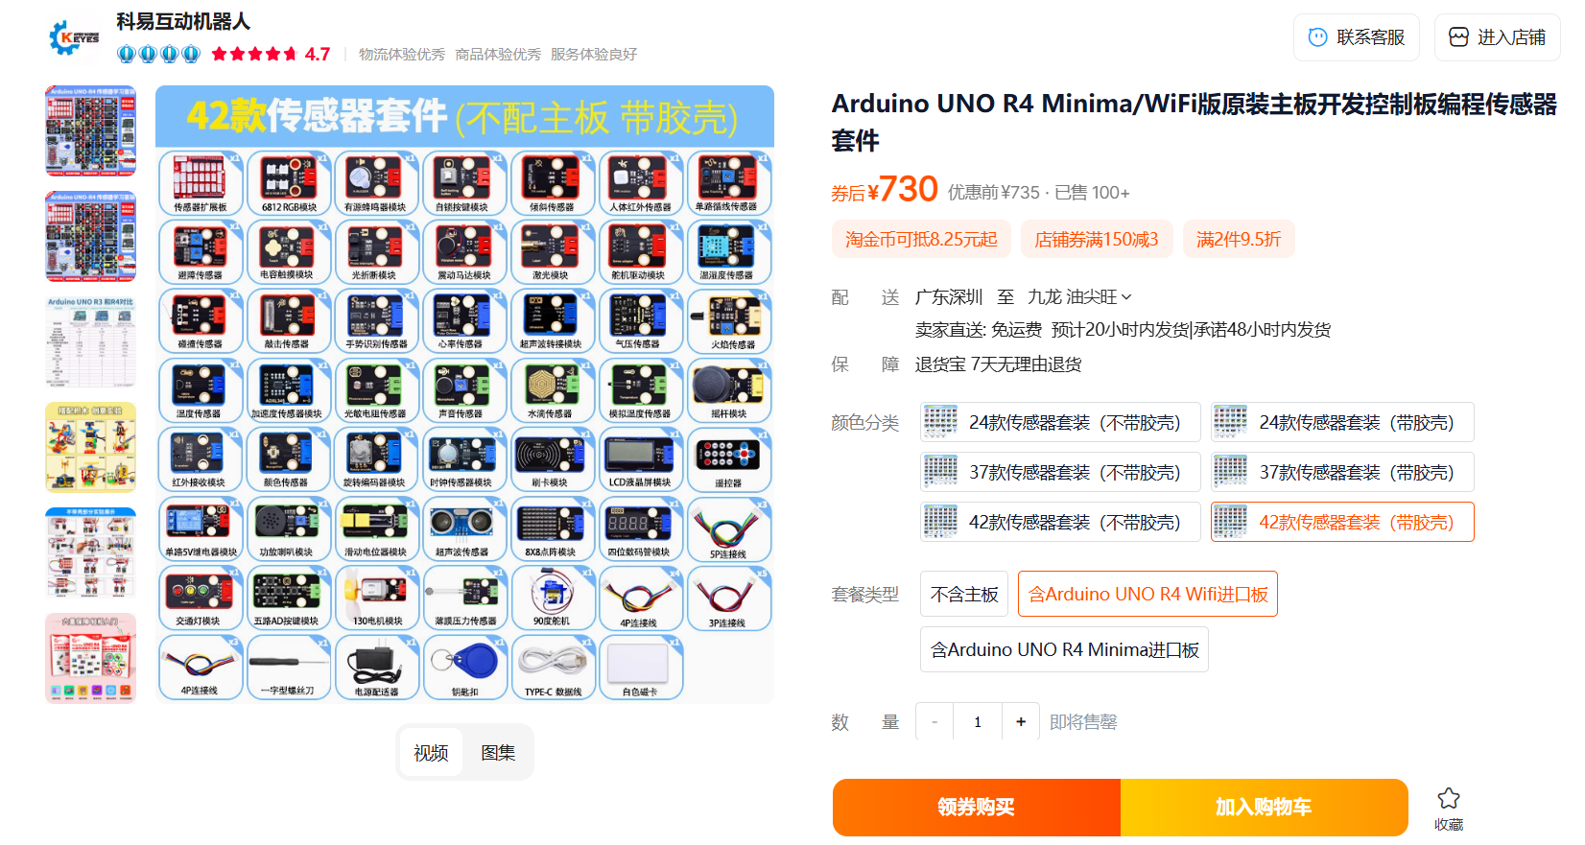

Item 2: Main Control - Arduino Uno R4 Wifi
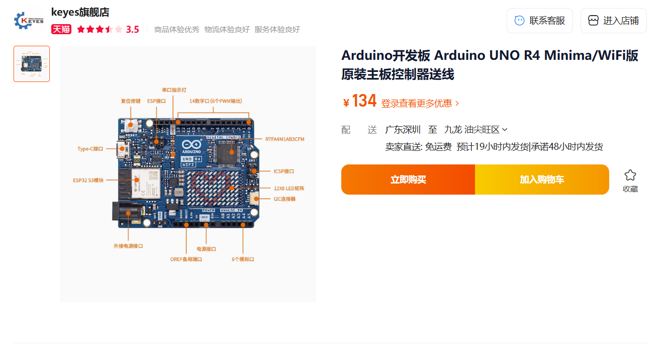

Item 3: Extension Board
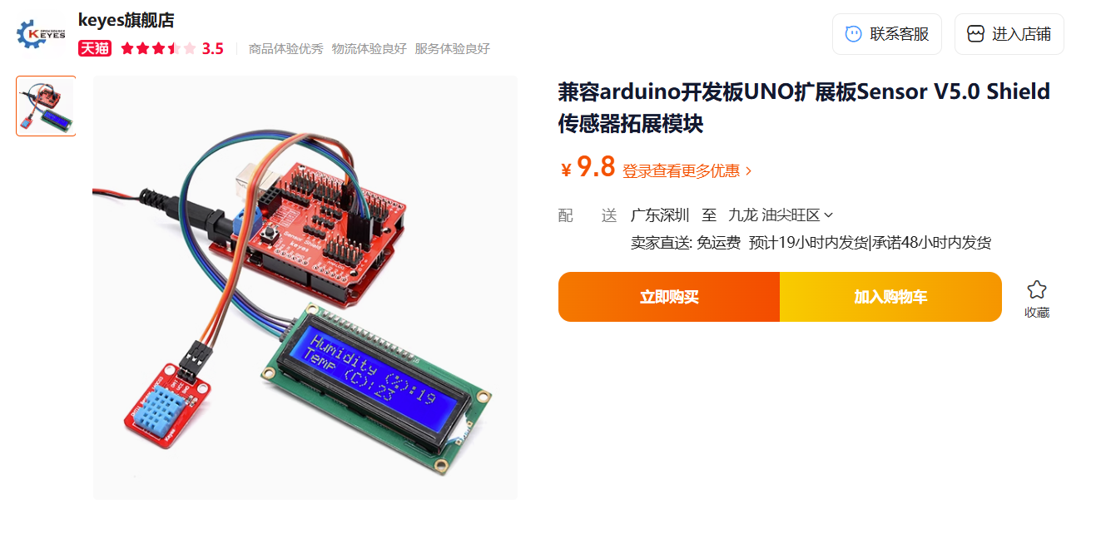

Item 4: Accelerometer
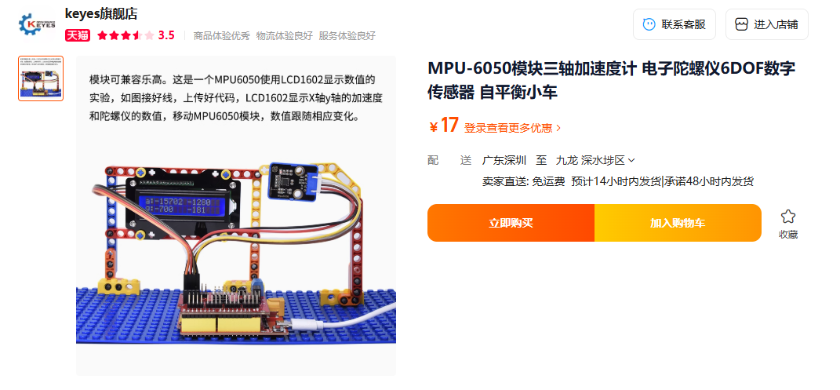

Item 5: RF Module
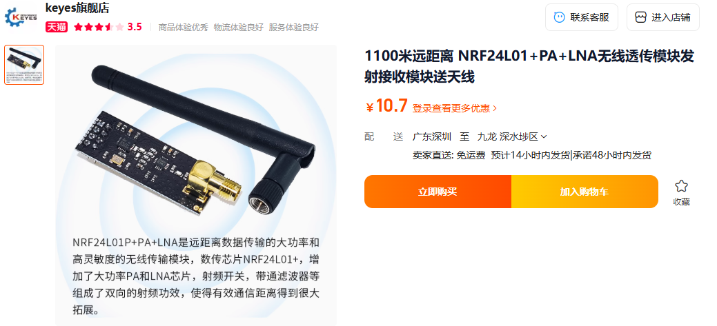
Item 6: RTC Component
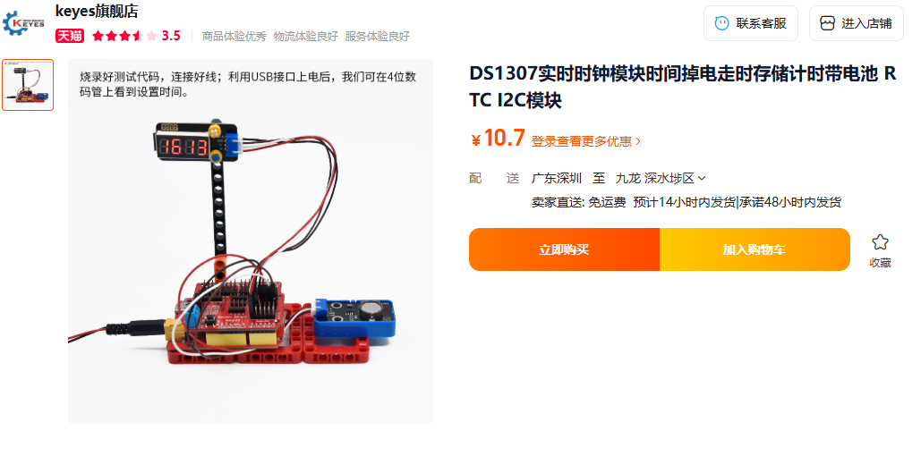

Item 7: Power Supply- Lithium Battery & Box
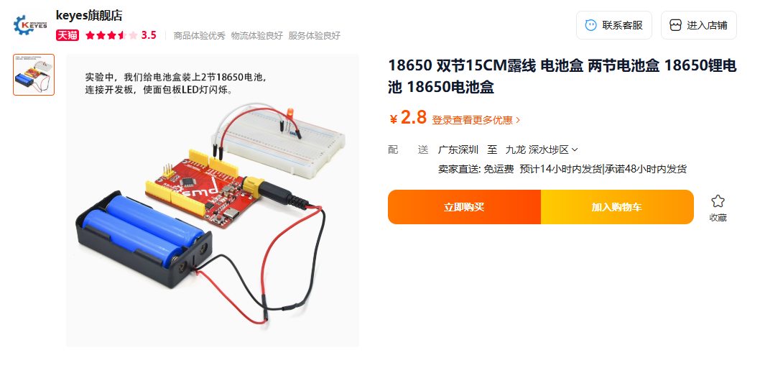
Item 8: Power Supply- Battery
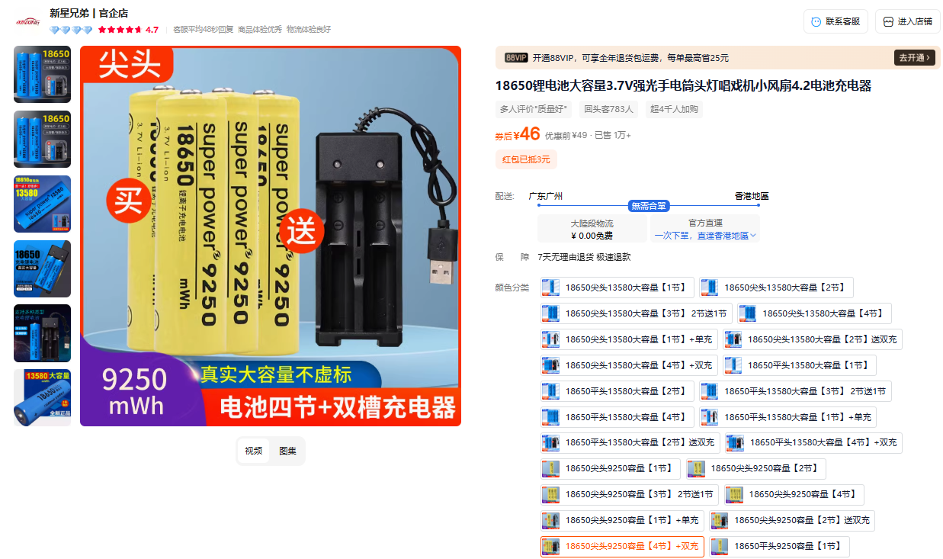

Item 9: SD Card Module
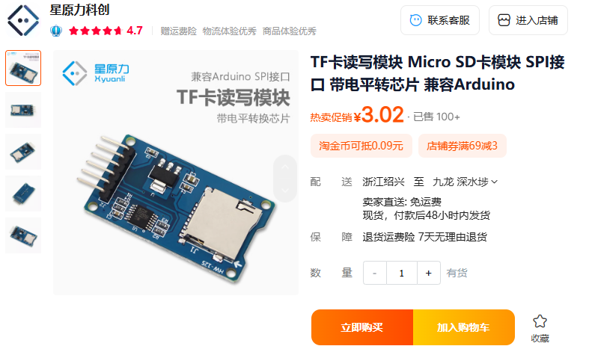
Item 10: SD Card
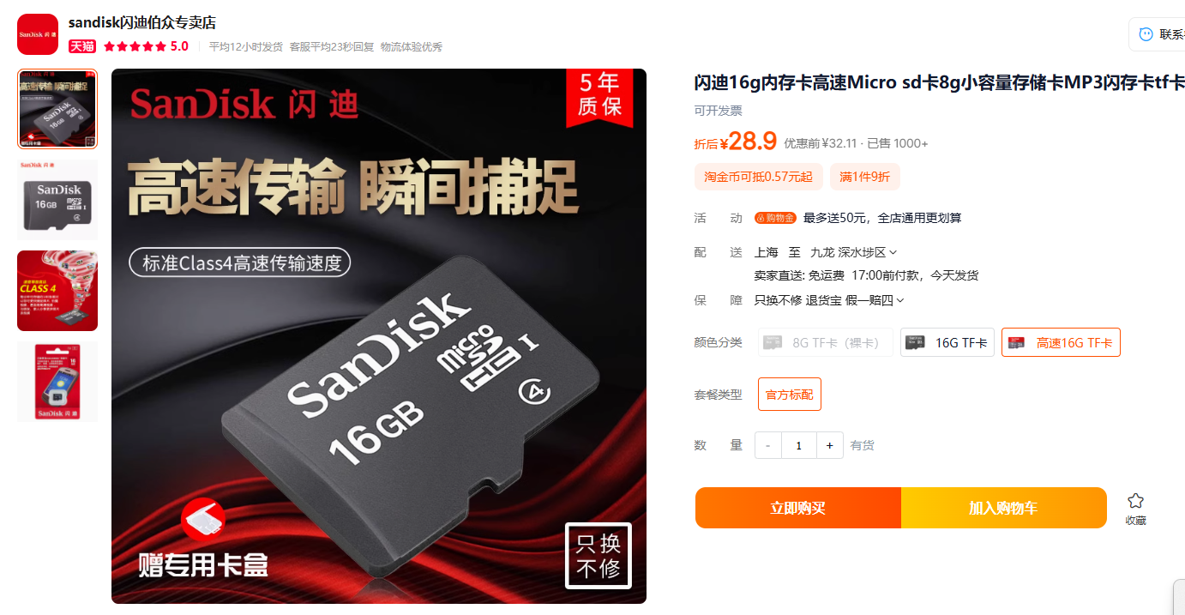

Item 11: Case
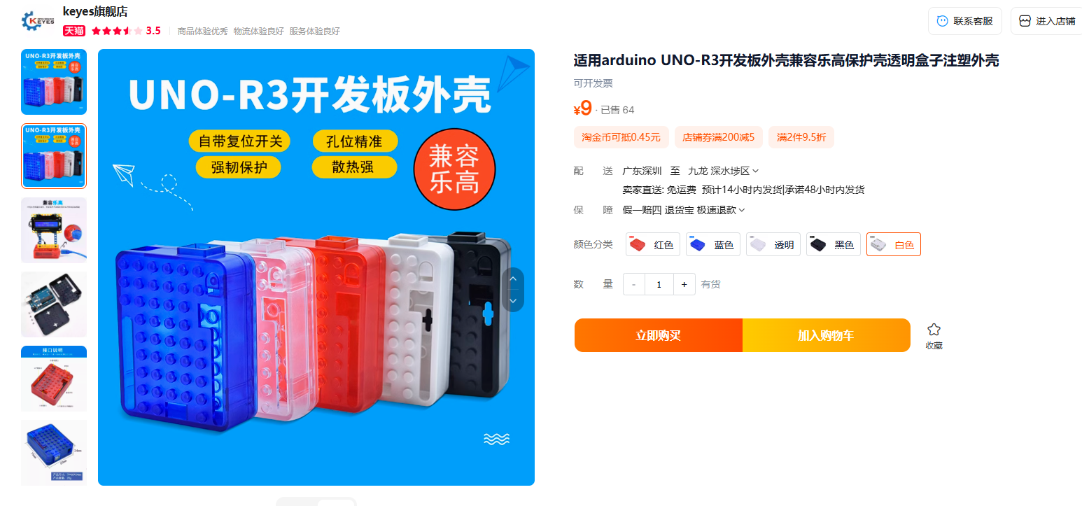
Item 12: 3D-print Case
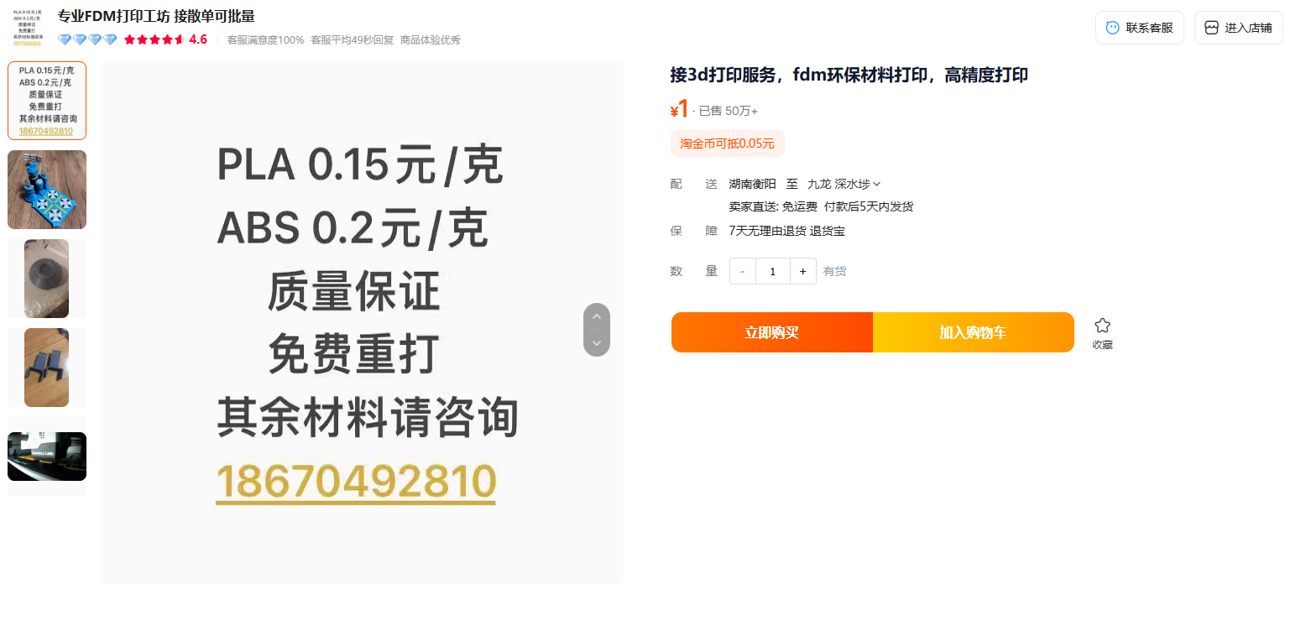

Item 13: Multimeter
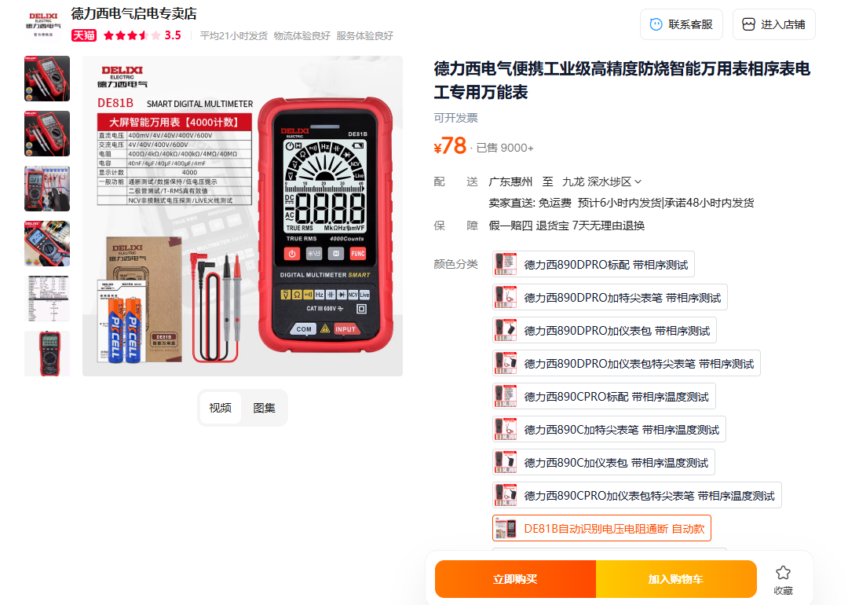
Item 14: Dupont Wire
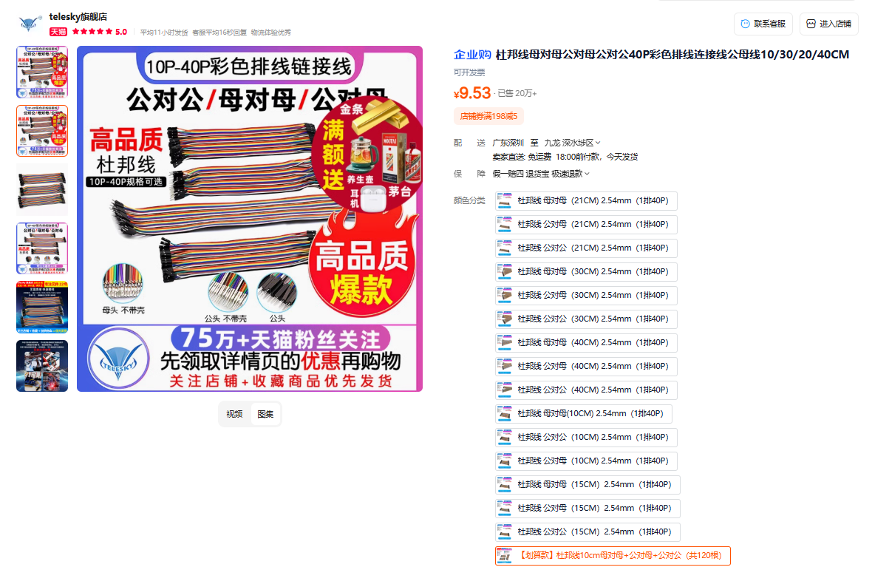

Item 15: Dupont Wire
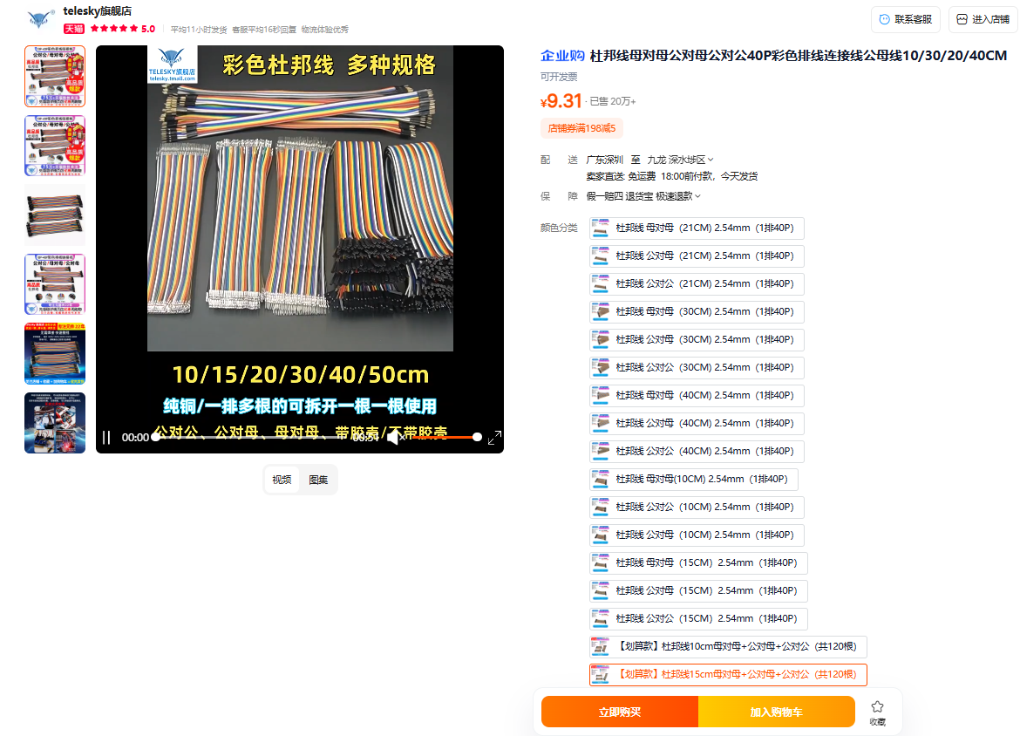
Item 16: Breadboard
